October 2021 Breakfast/Afternoon Snack Menu
Monday | Tuesday | Wednesday | Thursday | Friday
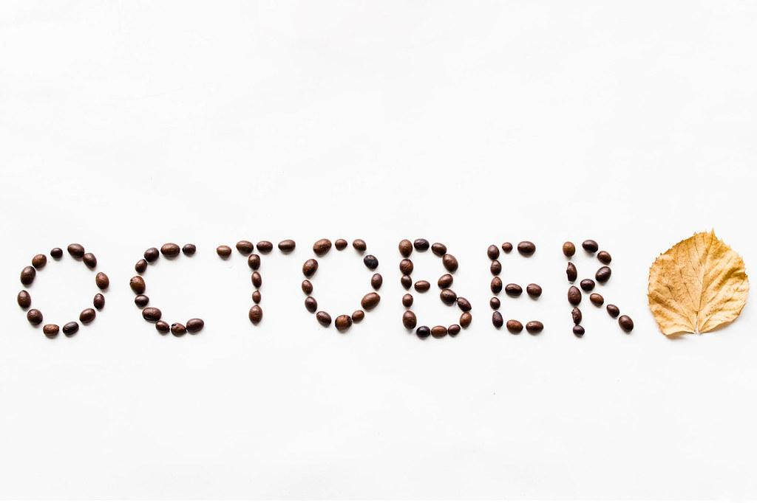 | 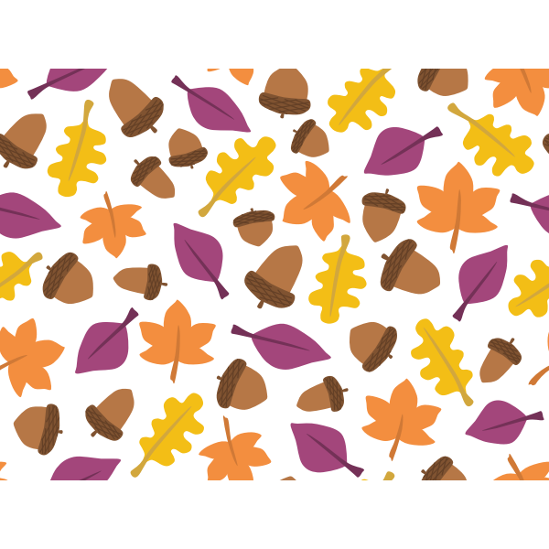 | 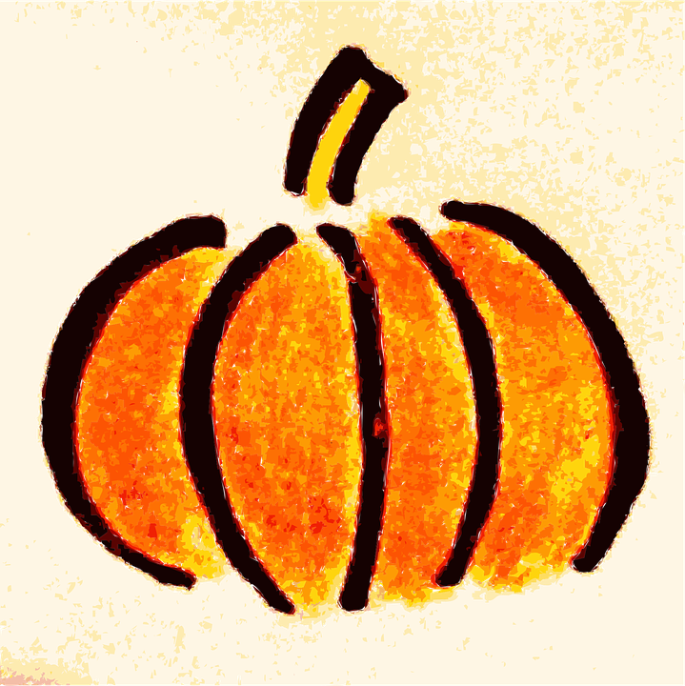 | 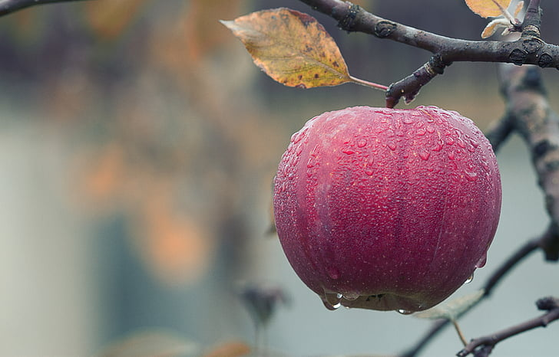 | 1  Bagel w/Cream Cheese  Berries  Milk  Pretzels & Juice
4  Cold Cereal  Bananas  Milk  Animal Crackers & Milk | 5  Blueberry Croissant Puff  Cheese Slices  Milk  Cucumbers with Dip & Crackers | 6  Yogurt  Strawberries  Milk  Pepperoni & String Cheese | 7  Berry Green Smoothie  Toast  Milk  Cowboy Caviar & Tortilla Chips | 8  Sausage in a Blanket  Blueberries  Milk  Side Salad & Crackers
11  Cold Cereal  Bananas  Milk  Carrot Sticks & Pretzels | 12  Egg, Sausage, Cheese Biscuit  Peaches  Milk  Mixed Dried Fruit & Milk | 13  Oatmeal  Blueberries  Milk  Mini Muffin & Pineapple | 14  Yogurt Parfaits  w/ Fruit  Milk  Cereal & Milk | 15  Waffles  Apricots  Milk  Cheese Slices & Grapes
18  Cold Cereal  Bananas  Milk  String Cheese & Apple Slices | 19  Biscuit & Gravy  Grapes  Milk  Fruit Salad & Graham Cracker | 20  Yogurt  Mixed Berries  Milk  Cottage Cheese & Peaches | 21  Sausage  Cantaloupe  Milk  StraBanana Smoothie & Toast | 22  English Muffins w/ Nut Butter  Pears  Milk  Cheerios & Juice
25  Cold Cereal  Bananas  Milk  Blueberry Crisp & Milk | 26  Breakfast Ham  Peaches  Milk  Cucumbers w/dip & Turkey | 27  Cream of Wheat  Strawberries  Milk  Hard Boiled Eggs & Crackers | 28  Mini Muffins  Grapes  Milk  Granola Square & Milk | 29  Pumpkin Pancakes  Raisins  Milk  Halloween Party!
October Lunch Menu
Monday | Tuesday | Wednesday | Thursday | Friday
 | 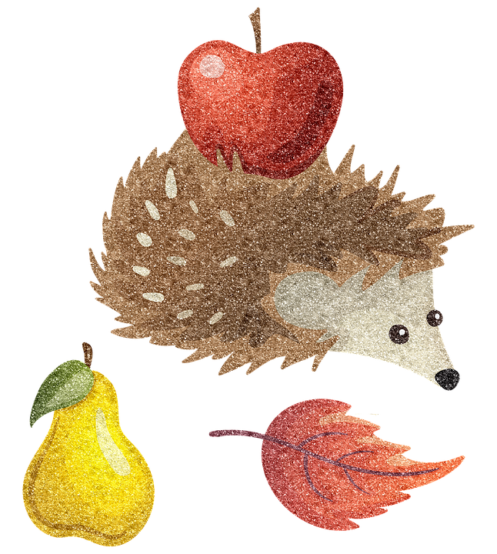 | 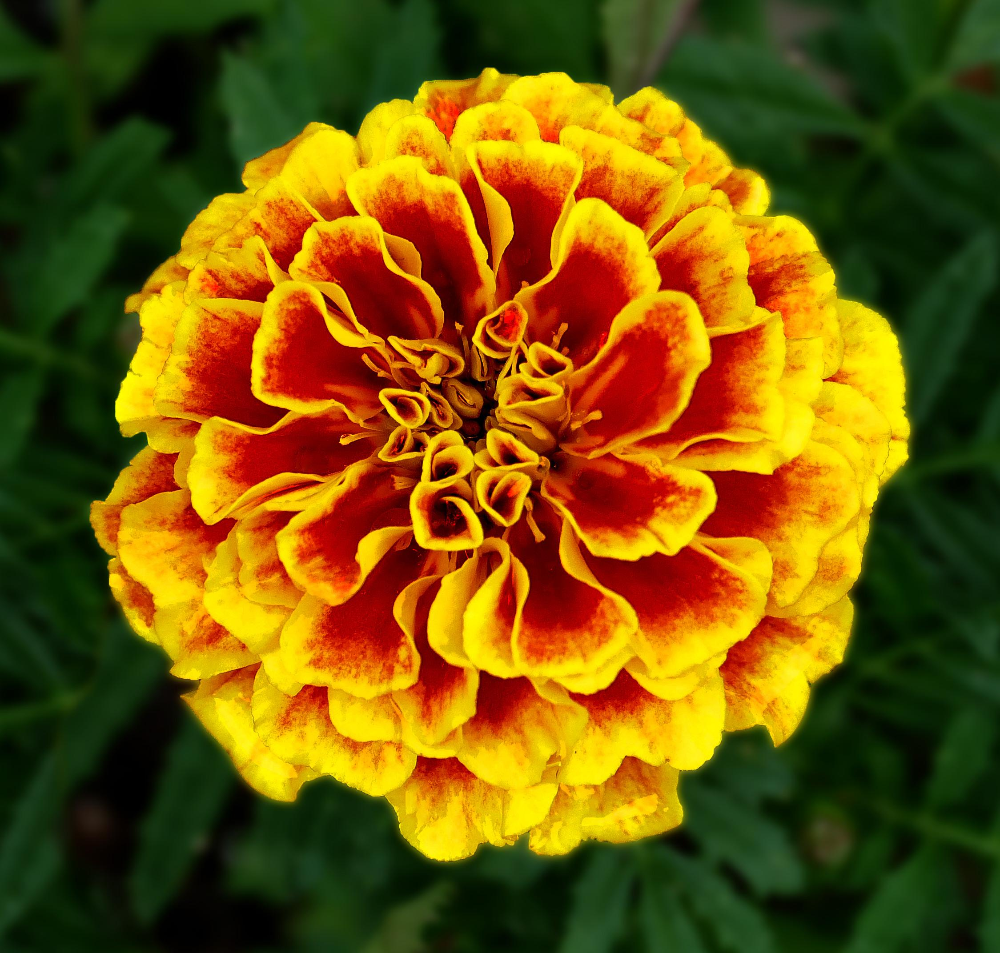 |  | 1  Chicken Salad Sandwich on WG Bun  Mixed Veggies  Fruit Cocktail  Milk
4  Ham, Cheese & Lettuce w/  WG Wrap  Peas  Applesauce  Milk | 5  Beef Pigs n Blanket  Corn  Fruit Cocktail  Milk | 6  Pasta Salad w/Veggies  Pears  Crackers  Milk | 7  Meatballs  Yellow Squash  Rice Pilaf  Melon  Milk | 8  Potato Soup w/ Ham  Carrots  Raspberries  Milk
11  Beef patty in Mushroom sauce  Mashed Potatoes  Apple Slices  Milk | 12  Chicken Pot Pie Soup  W/ Mixed Veggies  Peaches  Biscuit  Milk | 13  Beef Goulash WG  Mixed Veggies  Blackberries  Milk | 14  WG Grilled Ham & Cheese  Zucchini  Pears  Milk | 15  Loaded Chef Salad  w/Chicken  Kiwi  Crackers  Milk
18  Beef Sloppy Joes WG  Tater Tots  Broccoli  Blueberries  Milk | 19  Spaghetti Squash w/ Sauce  Mangos  WG Butter Bread  Milk | 20  Beef Little Smokies  Corn  Mixed Fruit  Roll  Milk | 21  Sub Sandwiches  Cucumbers  Strawberries  Milk | 22  Chicken Quesadilla WG  Guacamole & Chips  Mandarin Oranges  Milk
25  Shredded BBQ Chicken Slider WG  Baked Beans  Berries  Milk | 26  Beef and Broccoli w/ Rice  Pineapple  Milk | 27  Turkey w/Gravy  Sweet Potatoes  Tropical Mix  Roll  Milk | 28  Chicken & Cheese Roll-Ups WG  Snap Peas  Applesauce  Milk | 29  Chilli Dogs on WG Bun  Corn  Banana  Milk

